**ID:23676**

**Project Title: BK Arena Rwanda Ticket Booking**

**Project Description**: BK Arena Rwanda Ticket Booking it’s an Online Web Application system that allows Customer such as youth to book ticket for different events.

**Requirements BK Arena Rwanda Ticket Booking**

Are divided into two parts Functional Requirement and Non Functional Requirement

**Functional Requirements**

Functional requirements define the specific functions, features, and capabilities that a system must possess to meet the needs of its users. They describe what the system is supposed to do and how it should behave in different situations. Functional requirements are typically expressed in terms of input, process, and output. Here is some functional requirement for arena

* Users should be able to create accounts with a valid email address and password.
* Secure login functionality with proper authentication mechanisms.
* Client should be able to book ticket
* Admins should be able to modify clients details and delete clients.
* Admins should be able to search clients.

**Non Functional Requirement**

These are the aspects of a system that describe how it should behave, rather than specific features or functionalities (these are the quality attribute of the system) such as

* Data Encryption
  + All sensitive data, including user information details, should be encrypted during transmission and storage.
* Authentication and Authorization:
  + User authentication and authorization processes should be robust, ensuring that only authorized users can access specific functionalities.
* User Interface Responsiveness:
  + The user interface should be responsive and provide a consistent experience across different devices and browsers.
* Code Maintainability:
  + The codebase should be well-documented and adhere to coding standards to facilitate easy maintenance and future development.
* Browser Compatibility:
  + The system should be compatible with commonly used web browsers, including Chrome, Firefox, Safari, and Edge.

**Purpose of the project**

Develop a modern and user-friendly web application using html, CSS and Spring Boot.

Implement secure authentication and authorization mechanisms using Spring Security.

Create RESTful API endpoints for managing events and user data.

Build a responsive and accessible user interface for clients and administrator

Conduct testing and quality assurance to ensure functionality, performance, and security.

Provide user documentation and training materials for end-users.

**Project Limitation**

* Customizing the system for specific business requirements may be complex and require a deep understanding of the system architecture.
* Despite implemented security measures, the system may still be vulnerable to breaches and requires ongoing monitoring.

**Expected Outcome**

At the end of this project, we want to provide our valued clients with a user-friendly and efficient ticket booking system that is very intuitive and simple. Our goal is to deliver a flawless platform that not only fulfills but surpasses our users' expectations by providing them with an easy and pleasurable booking experience.

Project Plan

**Scope of the project**

This system is custom-designed for Arena Rwanda and it includes user-friendly interfaces, prioritizes efficiency, error reduction, and a positive booking process. robust security, meeting the unique needs of Arena Rwanda's ticketing operations

**Project Timeline:**

* Day 1:

Define project scope, requirements, and goals.

Set up development environment such as Spring Boot.

* Day 2:

Implement user authentication and authorization using Spring Security.

Create API endpoints and test it in postman.

* Day 3:

Build interfaces for frontend using tymeleaf with Css and Html and JavaScript for validation.

Integrate API endpoints for CRUD (Create, Read, Update and Delete).

* Day 4:

Build interfaces for frontend using tymeleaf with Css and Html and JavaScript for validation.

Integrate API endpoints for CRUD (Create, Read, Update and Delete).

Fixing errors for Spring Security

* Day 5:

Test the application for functionality, performance, and security.

Debug and fix any issues found during testing.

* Day 6:

Carry out final testing and quality control inspections.

Provide end users with training materials and user documentation.

Get ready for launch and tell users about the application.

testing that require additional development and fixes.

**Resources used to Complete the Project**

Here are Technological resources used for project

**Backend development**

Spring boot

With dependencies such as: spring security, spring web

MySQL (database)

Postman (to test API)

**For front end**

Thymeleaf with Css, Html and JavaScript

**User Documentation**

This is technical documentation information designed to assist end users in understanding how to use a product and troubleshooting typical problems. End users are clients or users who regularly set up and utilize a product.

This is the home page where you can register if you don’t have account or login if you have account

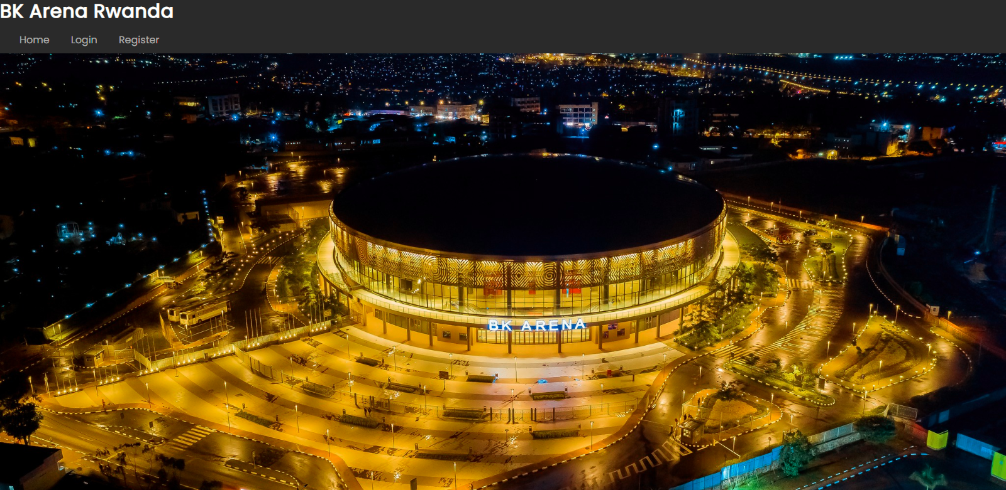

This is the registration form for helping users to register in order to have account (you can register as Admin (which is super user) or User)

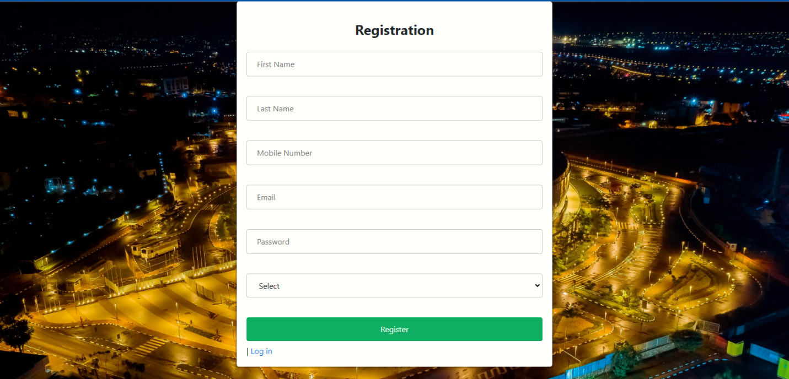

Login as client

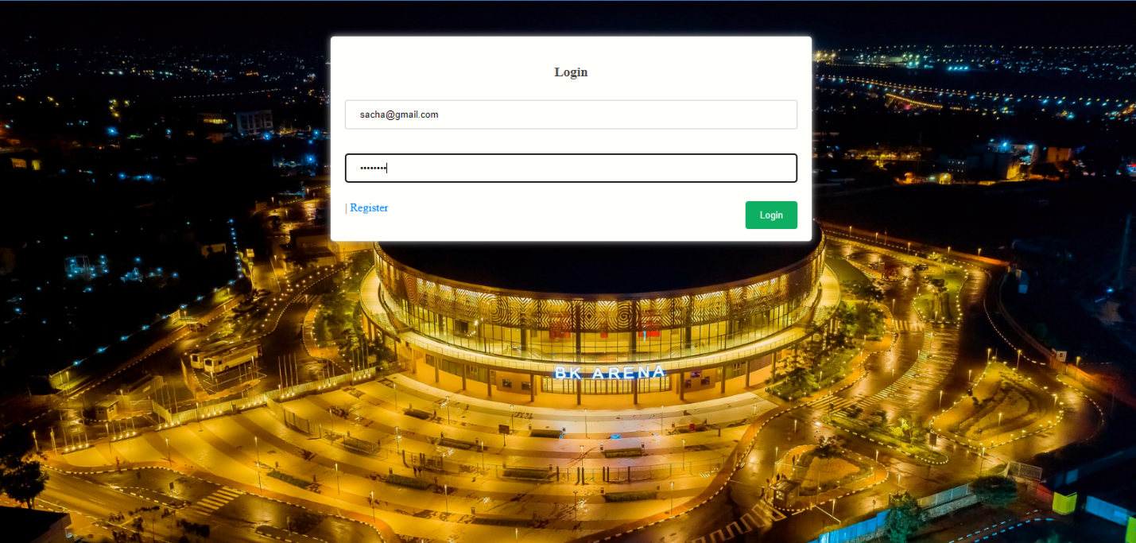

After logging in, clients are redirected to the home page, where they can view their email and type. On this page, they have the option to book tickets, navigate back to the home page, or log out. 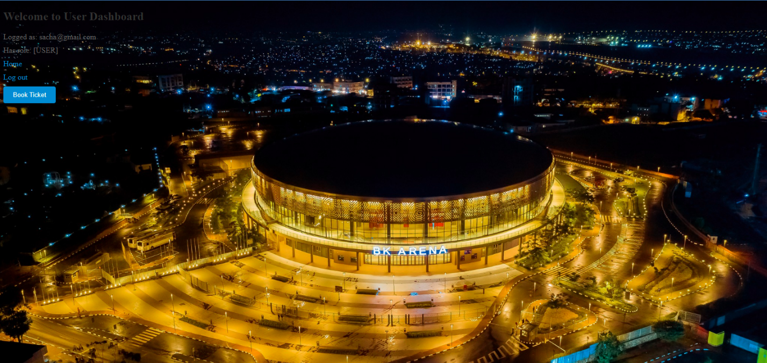

If clients click on 'Book Ticket,' they will be redirected to a page where they can proceed to book tickets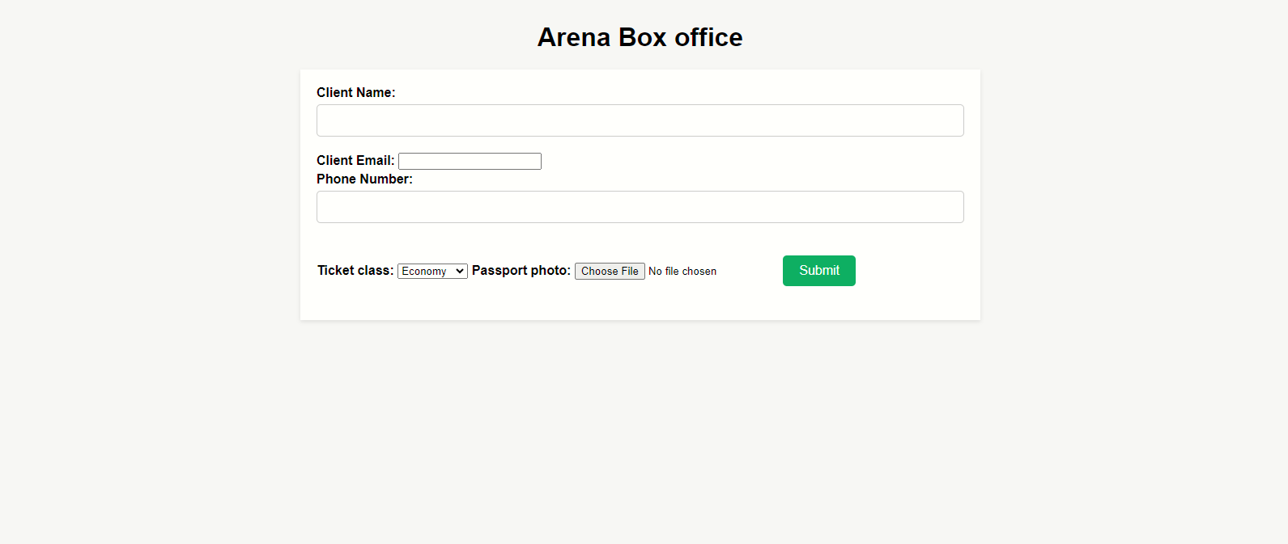

Login as Admin

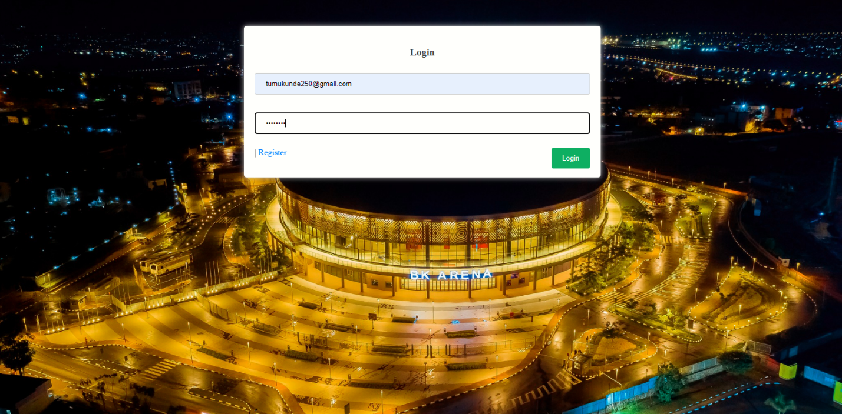

After logging in, admin is redirected to the dashboard, where they can view booked tickets and. On this page, they have the option to view tickets navigate back to the home page, or log out.



Admin has the right to view, edit, or delete tickets, as well as perform search operations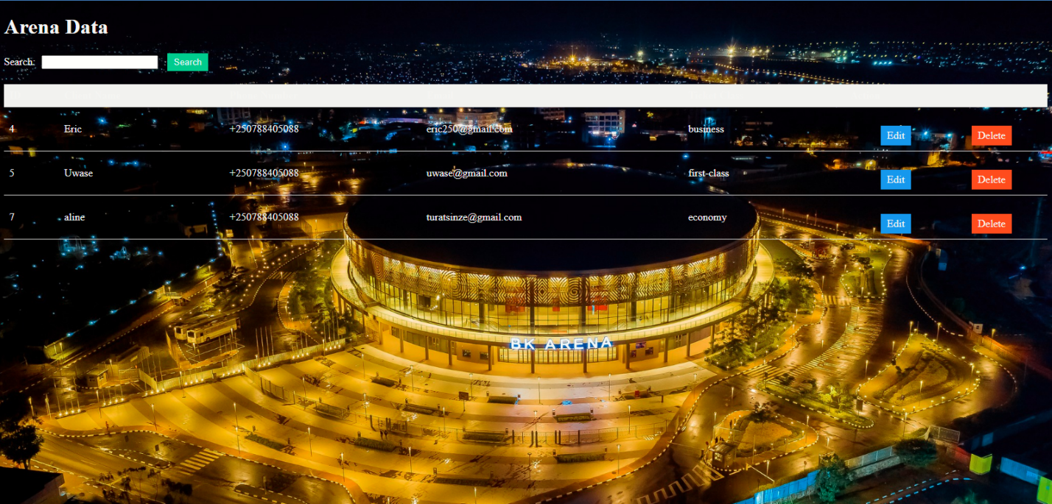

If admin clicks on edit button this page will be prompted to allow him to modify existing data.

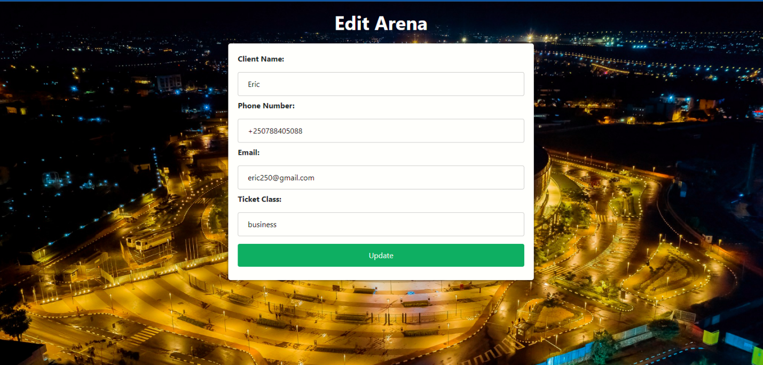

If admin clicks on delete button the pop up message will be display to ask him if he want to delete if yes data will be delete and also he has ability to search tickets.

